4Pi-BRAINSPOT Supplementary Analysis Toolbox for
Interferometric Ultra-High Resolution 3D Imaging through Brain Sections
Hao-Cheng Gao^{1,†}, Fan Xu^{1,2,3,†,*}, Xi Cheng⁴, Tailong Chen^{2,3},Cheng Bi¹, Yue Zheng¹, Yilun Li¹, Yumian Li^{2,3}, Alexander A. Chubykin^{4*}, Fang Huang^{1,5,6*}
1 Weldon School of Biomedical Engineering, Purdue University, West Lafayette, IN, USA
2 School of Optics and Photonics, Beijing Institute of Technology, Beijing 100081, China
3 School of Medical Engineering, Beijing Institute of Technology, Zhuhai, 519088, China.
4 Department of Biological Science, Purdue University, West Lafayette, IN, USA
5 Purdue Institute for Integrative Neuroscience, Purdue University, West Lafayette, IN, USA
6 Institute for Cancer Research, Purdue University, West Lafayette, IN, USA

†These authors contributed equally: Hao-Cheng Gao, Fan Xu

*Correspondence to: xufan@bit.edu.cn (F.X.), chubykin@purdue.edu (A.A.C), fanghuang@purdue.edu (F.H.);

STEP-BY-STEP GUIDE
- Open file ‘..\Analysis3D_main.mat’
- Change folder path in Line8 and file in Line9 to target folder and target file.
- Change parameters between Line17-20.
  - para.Recon_color_highb : reconstruction contrast, lower value will provides a higher contrast.
  - para.tk : cross section thickness, unit in nm.
  - para.wk : cross section width, unit in nm.
  - para.k : the running window number of cross sections will be 2k+1.
- Run the code
- ‘Input subfolder name (Return 'NP' to stop):’ will pop up in command window. Enter the name for subfolder of analyzed result.
- A gray XY projection will be shown. Use mouse left click to select points along interested spines and the selected points will be shown by yellow number on the image. To quit selection, right click the mouse at any position. Selected points will be saved in ‘Select.txt’
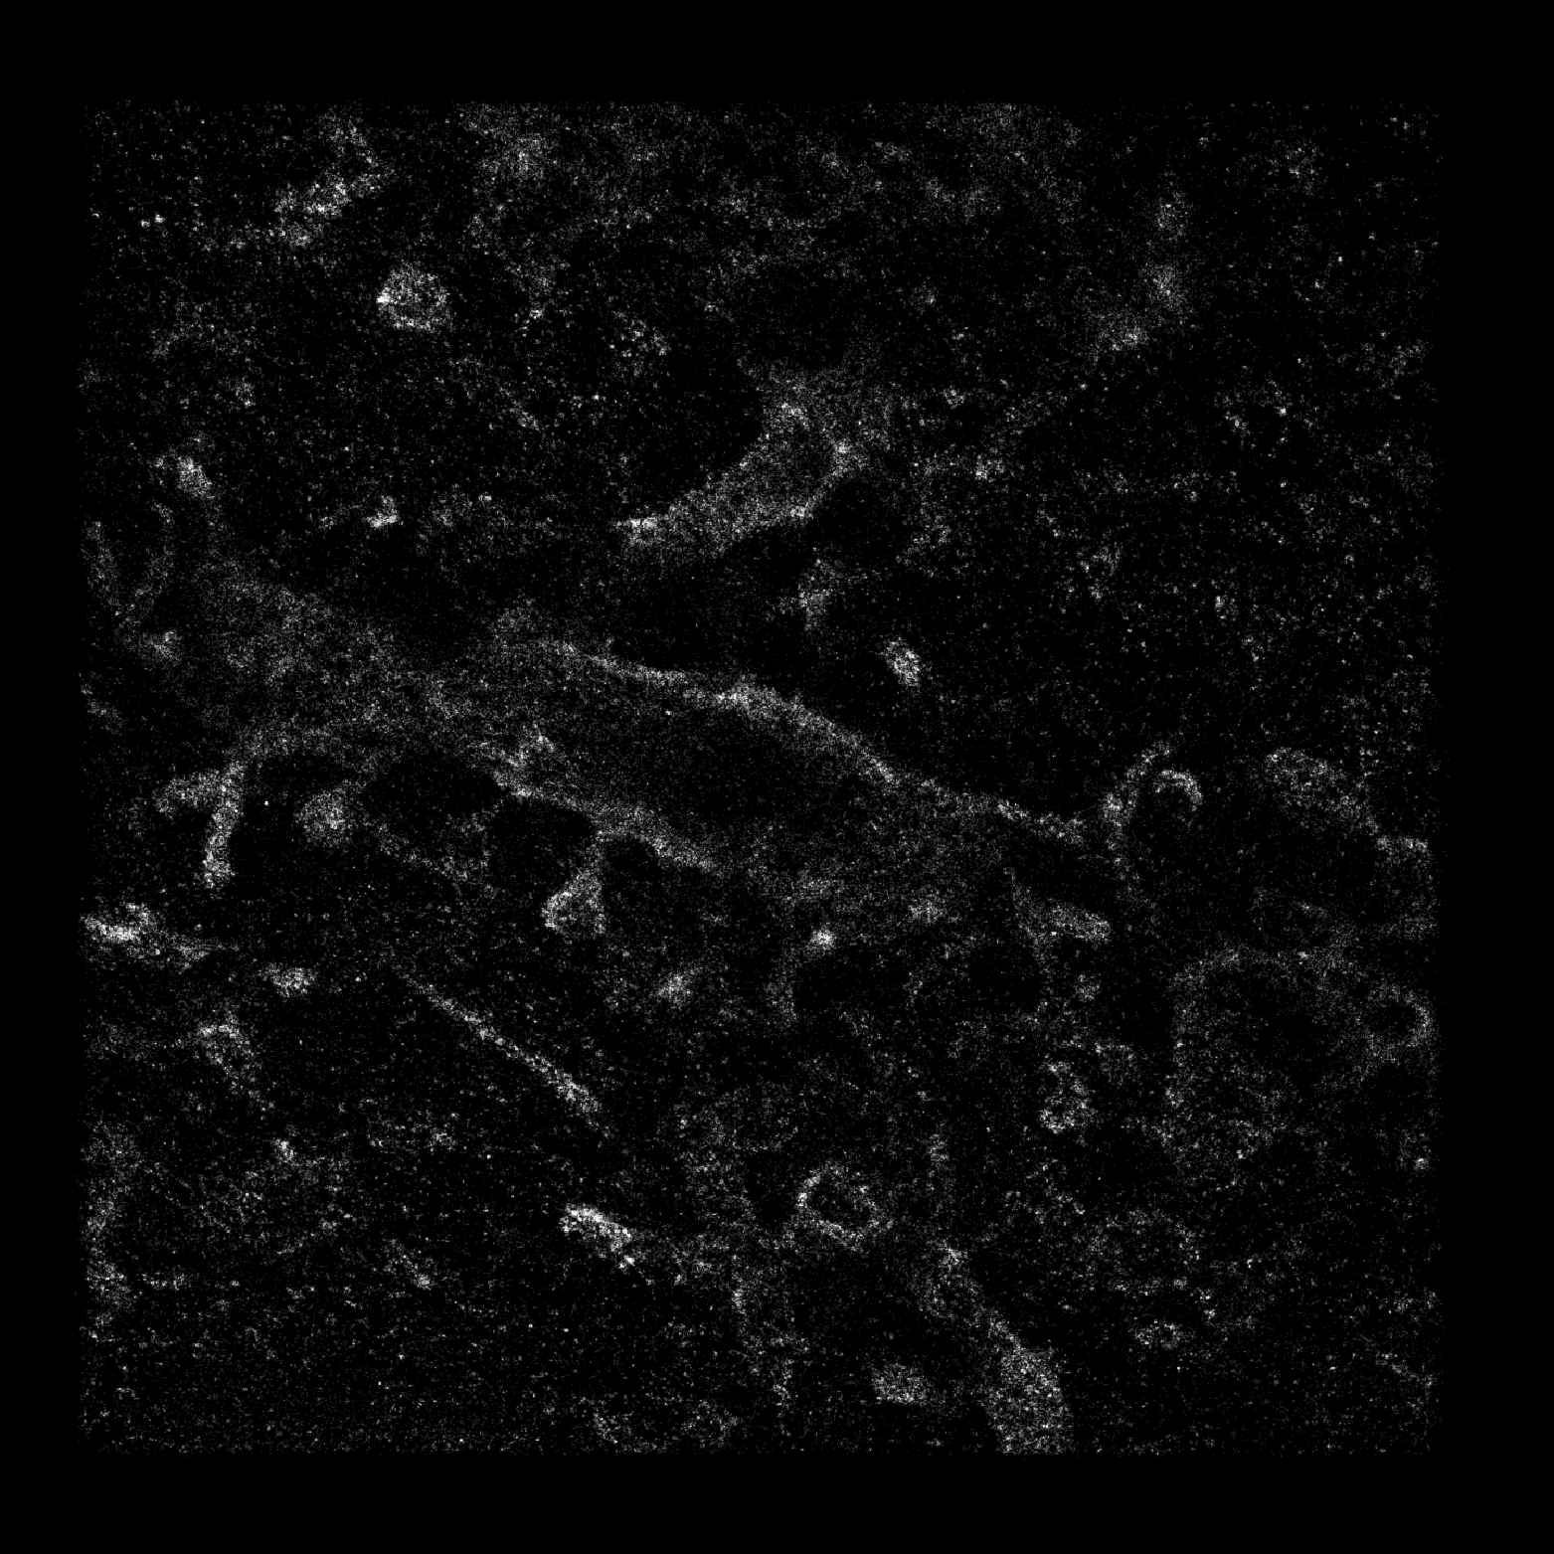 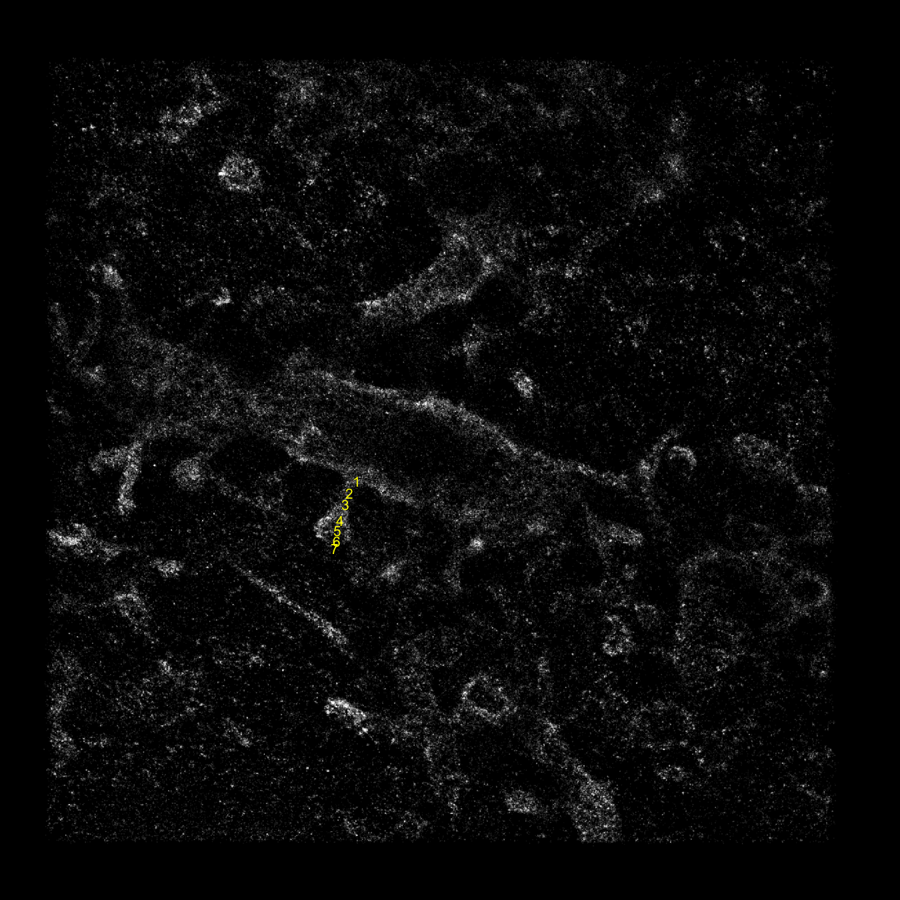
- Depth-colored XY projection with cross sections along selected points will be shown and saved as ‘Selected_ROI.tiff’ and ‘Selected_ROI_Enlarge.tiff’
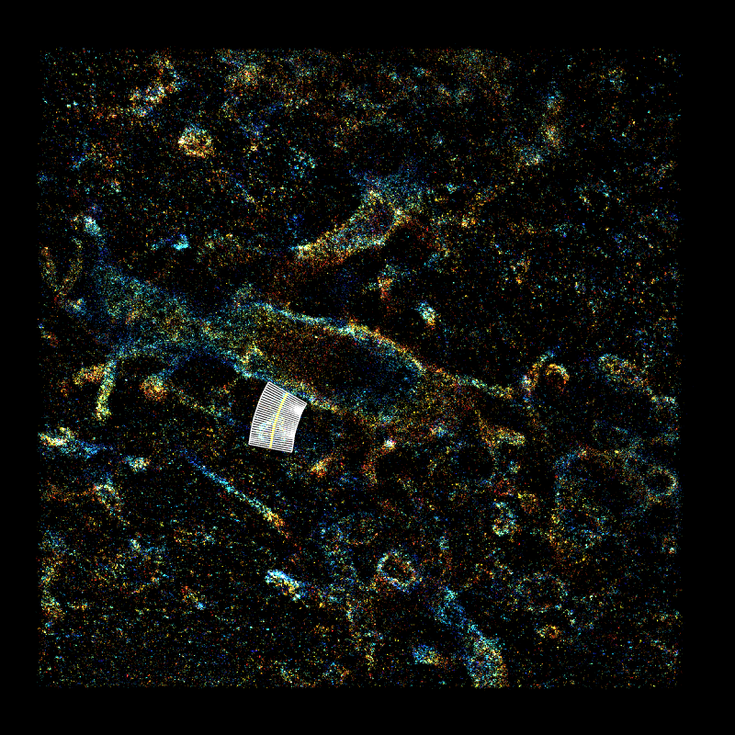 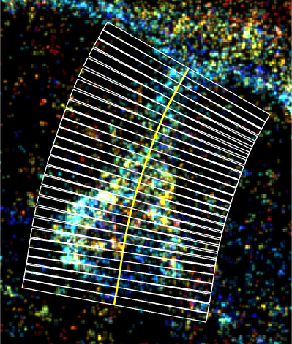
- A depth-colored YZ cross section will be shown. Use mouse left click to top and bottom boundary of the spine. The selected boundary will be plotted by yellow line.
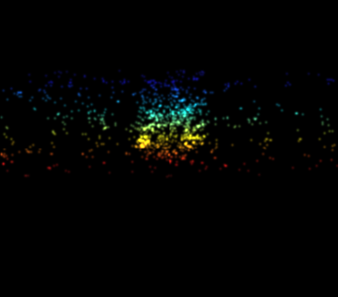 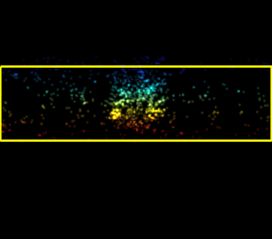
- The code will process cropping and analysis respectively, and the progress will be printed on command window. The process result will be saved as ‘Area.txt’, ‘Result_mid.mat’ and ‘Result_final.mat’. The visualization of cross section and fitting area will be saved in folder ‘\Area’.
- The estimated area at each position will be shown and ‘Input outlier position array (ex: [3,29])/(Empty for no) :’ will pop up in command window. Enter the points with less reliability or directly press enter to continue.
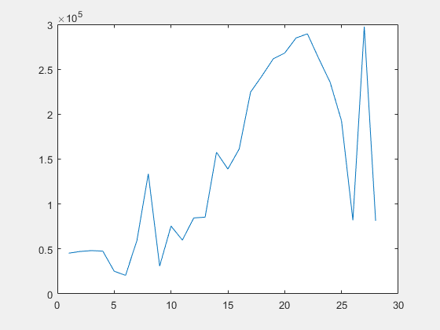
- Depth-colored XY projection of straighten spine and its corresponding smoothing-spine-fitting area curve will be shown and saved as ‘Selected_ROI_straight_XYs.tiff’ and ‘Selected_ROI_straight_Area.tiff’. All parameters will be saved in ‘Parameter.txt’.
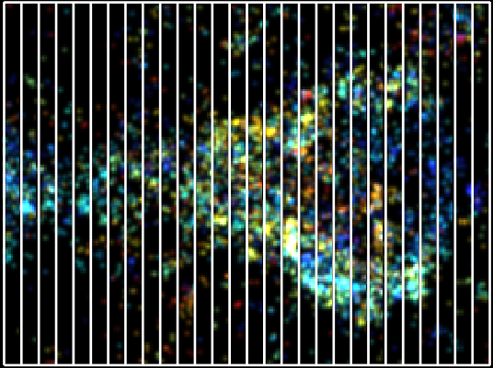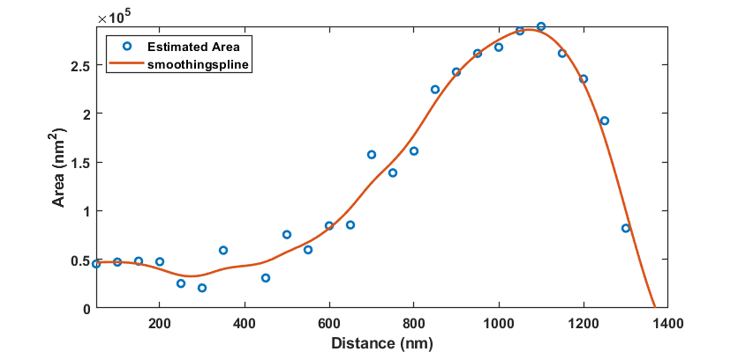
- Repeat 5-11. To quit processing, directly press enter during Step 5.

SOURCE CODES
‘Main’ folder
Analysis3D_main.m Main script for running supplementary analysis

‘Functino’ folder
Analyssi_spine_area_3D Script for analyzing cross-sections
Analysis_spine_section_3D Script for segmenting localizations along the tracing
cHistRecon.mexw64 Mex function for 2D Gaussian distribution rendering
cmap6.mat Default color map
fit_ellipse.m Script for ellipse contour fitting
interparc.m Script for 2D interpolation
myginput.m Script for region selection from image
pickspot.m Script for point selection from image
srhist_color_ca.m Script for generating color-coded super-resolution image

